Annual Report to the MOBAC Administrative Council

Fiscal Year Reporting on: 2022

Committee Name: Resource Sharing Committee

Committee Chair: Co-Chairs: Katya Haskin (MPC), Rochelle Eagan (SJB)

Active Committee Members: Rachel Becerra (GAV), Madeleine Damon (SCZ), Rochelle Eagen (SJB), Lydia Gentry (MIIS), Katya Haskin (MPC), Ray Melendez (MCO), Mezairah Niduaza (HCL), Donna Teresa (MPC), Jillian Wilson (WAT)

Date: 7 September 2022

- What did your committee accomplish during the last fiscal year?

During the course of the year as the COVID-19 pandemic continued to be an issue we continued to meet via ZOOM. We scheduled four (4) meetings throughout the fiscal year: July 27th 2021, October 12th 2021, January 11th 2022, April 12th 2022. The Courier Service has resumed a more consistent schedule as we move out of the pandemic. All committee meetings continue to include sharing information, discussion for problem solving, services offered and resource sharing practices.

Meeting Highlights:

July 27th 2021,
Former Committee Chair, Irma Fink’s (NPS) final MOBAC RSC meeting. Tentative discussion of who will take over the responsibilities. Rochelle Eagen (SJB) and Katya Haskin (MPC) volunteered, but a decision was not made at this meeting. Additional discussion of libraries reopening after being closed during the course of the pandemic, procedures and patron handling.

October 12th 2021,
Rochelle Eagen (SJB) and Katya Haskin (MPC) agreed to co-chair the RSC Committee for the 2022 fiscal year. Libraries continue to reopen, problem sharing as new issues arise with COVID-19 policies and mandates. Maddy Damon (SCZ) attended a conference and shared what she learned (book linked below).
https://kpu.pressbooks.pub/indigenousinformationliteracy/

January 11th 2022,
Continued problem solving discussion. Updates on KOHA ILS and the Technology committee. Ongoing renovations with the Santa Cruz Public Library branches and its progress. Rebecca Burgeon (CSUMB) attended the OCLC conference and learned how to use ILLiad and how to automate it.

April 12th 2022,
Discussion of what to include in the annual report. Rebecca Burgeon’s (CSUMB) final meeting before her retirement. The usual problem solving discussion.

- What activities, workshops, etc. are you planning for the current fiscal year?

- We will continue to explore ILL tools that facilitate the sharing of electronic resources and e-books.
- We will continue to gather and share information about ILL-relevant conferences, resources, and workshops.
- We will continue to find the best information and updating the MOBAC ILL Guidelines as needed. Adding useful links and ILL “best practice” tips.
- We will reach out to members unable to attend meetings to solicit input for the meetings. We will continue meetings via ZOOM until we are able and urged to gather in person once more.
- We will reach out to libraries with members that have retired and connect with their replacements, urging them to participate in this committee.

- Are there any obstacles/issues/challenges you wish to convey?

- As usual, we would like to see what we can do as a committee to encourage and facilitate resource sharing among all MOBAC member libraries.
- Due to the changing nature of digital content, we are working to keep up with new technologies.
- As we are moving out of the COVID-19 pandemic, we are working to continue provide services safely.
- We request that the Council encourage full participation of MOBAC member libraries in resource sharing.
- We request that the Council encourage full participation of member libraries’ designated Resource Sharing Committee representatives at our quarterly Resource Sharing Committee meetings.

Estimate funding need for current FY: We are not requesting fund at this time.

Annual Statistics – FY 2022 (June 2022 – July 2021)
The statistics presented in green (pgs 3-4) represent the overall activity of MOBAC as Lenders.
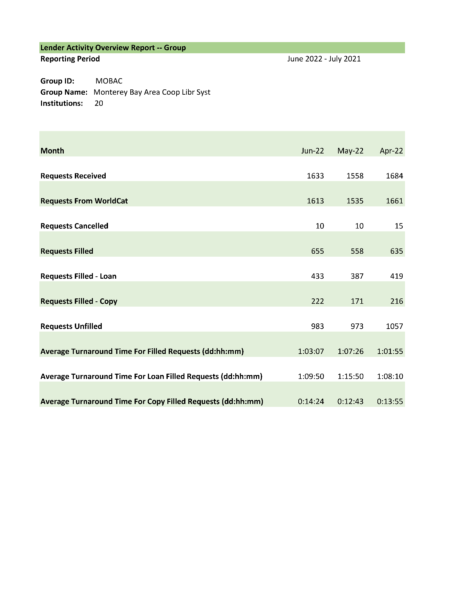
The statistics presented in blue (pgs 5-6) represent the overall activity of MOBAC as Borrowers.
