MOBAC Resource Sharing Committee Meeting Agenda
Tuesday, April 13, 2021
1:00 pm – 3:30 pm
Via ZOOM

Join Zoom Meeting
https://us02web.zoom.us/j/84362116116?pwd=WnJMSWR6V1Uxa1dZNVY2eFV4NmNZUT09
Meeting ID: 843 6211 6116
Passcode: 288656

- Call to Order and Introductions
Called to order at 1:08
Irma chaired and Lydia scribed
Jillian Wilson (WAT), Irma Fink (NPS), Ray Melendez (MCO), Rachel Becerra (GAV), Maddie Damon (SCZ), Lydia Gentry (MIIS), Donna Teresa (MPC), Dana Young (GAV)

- Addition(s)/Change(s) to the agenda
Nothing added

- Approval of the minutes of January 19, 2021 – draft minutes posted to the Committee’s website http://www.mobac.org/committees/interlibrary-loan-committee/ill-committee-events/
Lydia moved to approve, Ray seconded

- Reports

  - Administrative Council – March 19, 2021 meeting (Irma Fink)
    - One of the things that they did was approve the recommendation of the nominating committee for the 21-22 year: Jacqueline Grallo, Vice Chair (CSUMB - Frank has retired-Grallo is interim) and Hillary Thayer (MCO) as Chair.
    - The new rep for the PLP Executive Committee is Tom Rosko (NPS).
    - Irma presented our charge (thanks, everyone, for looking at it!) Inga from MPL spoke very nicely in favor of the ILL committee and broadening the charge to include “resource sharing”; Irma to talk to Katya from MPC (she did post to the website) to update all of the places where we have the charge listed and refer to ourselves as the ILL committee
    - Looked at 2021 OCLC contract—will act on it in the June meeting
    - Working website group has developed the framework and is looking at the revisions—Katya will know (we may have an update at some point)
    - Committee chairs are currently looking at the listservs and updating them; Irma reports that everything appears to be in order from when Jean Chapin left
      - Jillian will need some help to figure out what is going on with it, where to look, etc.
      - It’s supposed to be easier once it is taken over by PLP
      - Need follow-up
    - PLP has applied for a grant on social justice and freedom of expression
      - CLSA funds cut by 50%; this is to replace those funds

  - Technology Committee

  - Reference Committee

  - SPLAMBA

Update on March 19, 2021 ZOOM workshop
    - Rochelle may join in with an update later

  - Literacy Committee

- New Business
    - Problem with OCLC discovery services; system not prioritizing libraries with the most holdings
      - Irma notices that from one day to the next the holdings a search brings back can change
      - Many people have limited their service
      - (More conversation about this later in the meeting)

- Public Comment
    - No public comment

- Old Business

- MOBAC Website Redesign Working Group – Update (Katya Haskin)

A website redesign working group was formed consisting of a member for each MOBAC committee, Council and PLP staff. Katya Haskin (MPC) represents the ILL committee. SEE ATTACHMENT 2 below for website samples viewed at previous meeting.

    - Irma to email Katya

- KOHA ILS Committee – Update (Rochelle Eagen)

A 2-day workshop was planned for February.
- This is where the public libraries planning to transition to Koha will be interested in our expansion to resource sharing
- Come back to this if Rochelle joins us

- MOBAC Listservs and email reflectors

At their December meeting, the MOBAC Administrative Council approved moving the listservs and email reflectors to PLP administration. At our January Committee meeting, Jillian Wilson (WAT) volunteered to keep the Committee member roster and listserv updated. Katya Haskin (MPC) also indicated that she had been updating this information. How would we like to move forward? SEE ATTACHMENT 1 below for background.
- Irma to connect with Jillian and Katya offline to discuss this further

- The updated ILL Committee charge was unanimously approved by Council at its March 19, 2021 meeting:

MOBAC Resource Sharing Committee

The MOBAC Resource Sharing Committee is the advisory group, which makes recommendations to the MOBAC Administrative Council to improve and maintain resource sharing and interlibrary loan/document delivery service throughout the System with regard to efficient communication, accurate tools, and trained and efficient resource sharing/interlibrary loan staff.

** Note that updated Charge and Committee name should be updated on all our webpages
- Irma to talk to Katya about this

- Workshops (information only)

Copyright Clearance Center
Upcoming webinars: http://www.copyright.com/learn/courses-programs/webinars/
Past webinars: http://www.copyright.com/learn/media-downloads/past-webinars/

OCLC
Upcoming & recorded webinars: https://www.oclc.org/events/webinars.en.html

WebJunction (OCLC)
Free October Webinars for Library Staff https://www.webjunction.org/find-training/free-events.html

Miscellaneous OCLC Support during COVID-19

Realm Project – Reopening Archives, Libraries and Museums https://www.webjunction.org/explore-topics/COVID-19-research-project.html

OCLC COVID-19 – We’re in this together. Information and Resources to help https://www.oclc.org/en/covid-19.html

Spreadsheet listing the status of libraries: whether or not they are lending; whether or not they are accepting the return of materials https://docs.google.com/spreadsheets/d/1M8qEr7sAjTzG9v4fxIuwndEHosVF2UMcrXW00SeNd68/edit#gid=0

CapiraMobile (Capira Technologies is now part of OCLC)
https://www.capiratech.com/capiramobile

- Conferences

OCLC Midwinter – Virtual. Did anyone attend?
https://2021.alamidwinter.org/

Northwest Interlibrary Loan & Resource Sharing Conference – Virtual – September 1-3, 2021 https://nwill.org/

- Graham McGrew from UCSC used to go to this

Save the Date for Internet Librarian 2021 – October 26-28, 2021 – Monterey Marriott
http://internet-librarian.infotoday.com/2020/Default.aspx
    - Maybe onsite!!

- Announcements

Share plans for library re-openings, curbside delivery, restored ILL service, Courier Service (each member is encouraged to share)
    - Irma to Rachel to Dana – are you sharing resources? Does the courier go to your library?
      - No, not lending print materials, no reason for the courier to come by
    - Libraries should reach out to Yemila Alverez (PLS) to get the courier service reinstated when they are ready
    - Rachel—getting a lot of returns through the mail
    - GAV – working from home mostly, Rachel goes in when there is mail; Gavilan campus is closed. Hoping to reopen in the fall or summer (all instruction in online in the summer)
    - MIIS – lending and borrowing (no courier service)
    - MPC – lending and borrowing since last March; some reopening of the building in the Fall
    - WAT – full ILL services; starting Apr 5 did open first floor for 30 minutes (10 people at a time) – mainly children’s material, but also some floating shelves from adult and teen collection; starting May 1, opening Freedom branch for curbside services.
      - Irma asks, how do you manage that?
        - Each person receives a card that they give back, staff at the front door and reference librarians
        - People can’t just sit and hang out, but few problems
        - Circ desk is staffed as well
    - MCFL – curbside, lunch at the library at all branches, library by mail, zipbooks, 4 branches – in person at 25%, computer access; 4 more in May; ILL plan is to start in the fiscal year (may lose Zipbooks and better to start on a fiscal year deal)
      - Budget hasn’t been decided yet for ZipBooks
      - Courier goes to MCFL
    - SCZ – Maddie is in CMS department – deciding which collections go on which libraries – probably going to start in the new fiscal year, but a lot of things are still in flux; grab-n-go lobby service at downtown branch, limited computer usage – 45-minute use times, then disconnect; Capitola to reopen in June, Aptos to close when Capitola opens, Scott’s Valley closed, Felton open, Live Oak to close—it is a lot to keep track of!
    - NPS – new quarter started at the end of March- at a distance mode; Irma on-site with some others to keep services going; contactless service for people; no timeline for return to in-person. Construction in the building at the moment; most staff have been vaccinated
    - No special vaccination times for county employees?!
    - Conversation about vaccines
    - It has been hectic for all of us

- Problem sharing/solving
  - OCLC issue – when items are put into the search field, it used to prioritize the item with the most holdings, which is generally also showed the libraries closest; now they have to go to the 3rd page at times; recurring problem (was settings before, now not so much)
    - Ray to send informational emails to Jillian
  - Differences in lending volume since restarting lending

- Next meeting date(s)/location(s)

  - July 13, 2021, 1:00 pm (via ZOOM?) – Yes!
  - October 12, 2021, 1:00 pm

- Agenda items for next meeting

  - Need to get updates on website and Koha libraries
  - Irma to work with Jillian on email reflectors to get them good to go!

- Adjournment of Business Meeting
Meeting adjourned at 2:15

- News from the libraries
  - Ray – Bookmobile – “lean, green, reading machine” – to help outreach to schools—early childhood literacy aims
  - MCFL searching for a new ILS with an aim for spring ’22; not part of the Koha group because of problems with Koha and Polaris
  - Donna’s book club – two book selections at the same time to represent fiction and YA fiction because there are so many different age groups; plans to expand to include movies as well when the building open
  - Summer reading at Watsonville – take home kits for kids and adults; very successful one kit per week, “color your world,” virtual Ballet Folklorico
  - Other kits, virtual, and grab-and-go programming
ATTACHMENT 1

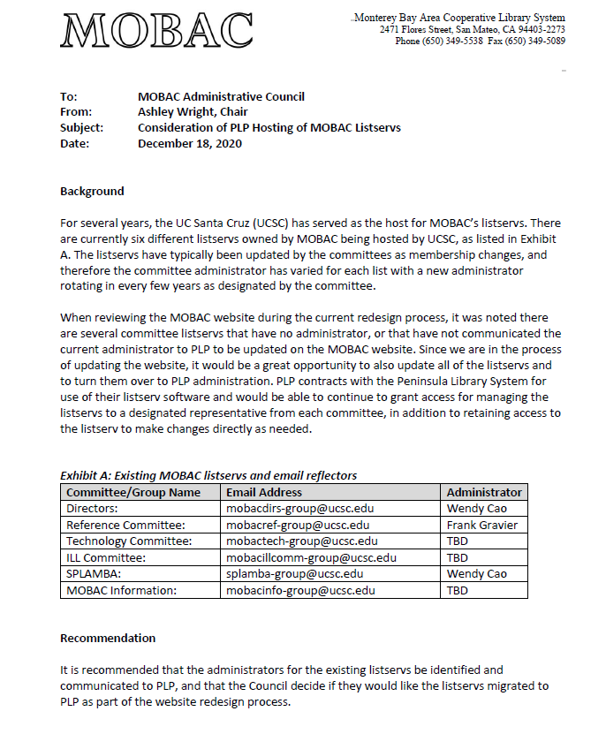

ATTACHMENT 2

