MOBAC ILL Committee Meeting Minutes
Tuesday, January 19, 2021
1:00 pm – 3:30 pm
Via ZOOM

Join Zoom Meeting
https://us02web.zoom.us/j/86841634424?pwd=dUU4NEJGYmFCN3owQWVqd3NENUdpQT09
Meeting ID: 868 4163 4424
Passcode: 863555

- Call to Order and Introductions
1:04 pm
Attendees: Katya Haskin (MPC), Lydia Gentry (MIIS), Irma Fink (NPS), Rebecca Bergeon (CSUMB), Ray Melendez (MCO), Maddy Damon (SCZ), Jillian Wilson (WAT), Rochelle Eagen (SJB), Mezairah Niduaza (HCL)

Scribe: Jillian Wilson (WAT)

- Addition(s)/Change(s) to the agenda
No changes

- Approval of the minutes of October 13, 2020 – draft minutes posted to the Committee’s website http://www.mobac.org/committees/interlibrary-loan-committee/ill-committee-events/

Ray/Katya
Approved

- Reports

  - Administrative Council – December 18, 2020 meeting (Irma Fink)
    - Irma attended; action items from the Council are on the Agenda below
    - PLP data privacy grant moving forward with train-the-trainer modules in March & April
    - Discussed a coordinated effort for National Library Week (4/4 – 4/10/21)

  - Technology Committee
Nothing to report

  - Reference Committee
Nothing to report

  - SPLAMBA

Zoom workshop with two speakers planned for March 19, 2021 on the subjects of yoga, mindfulness, & mental health for youth. Contact Alison Day for additional information dayaj1@co.monterey.ca.us

(Rochelle E.) The Zoom workshop is a continuation of what was originally scheduled for March 2020. That workshop was cancelled due to COVID and they moved the event online for this year. They also added a speaker. The Administrative Council approved a $200 stipend request for speakers.

  - Literacy Committee
Planning future workshops

- New Business

- MOBAC Listservs and email reflectors

At their December meeting, the MOBAC Administrative Council approved moving the listservs and email reflectors to PLP administration. Committees need to designate a representative to make changes as needed. SEE ATTACHMENT 1 below

Jillian Wilson (WTX) volunteered to keep the ILL Committee member roster & listserv updated; Katya Haskin (MPC) mentioned that she is currently updating this information on the website.

- Public Comment
No public comment

- Old Business

- MOBAC Website Redesign Working Group (Katya Haskin)

A website redesign working group was formed consisting of a member for each MOBAC committee, Council and PLP staff. Katya Haskin (MPC) volunteered to represent the ILL committee and will report and seek feedback from ILL Committee members. SEE ATTACHMENT 2 below

The priority of the redesign is to make info more accessible, especially with the Brown Act in mind, and to make Agendas easier to post and find.

Katya asked for feedback from the group on the three designs. The group seemed to like all the designs, leaning more towards 1 and 2. Overall feedback to the redesign group suggests design 2 is the favorite, but some elements from designs 1 & 3 would also be incorporated. For example, the carousel feature. Katya didn’t know what would be included in the carousel; Jillian suggested photos of MOBAC libraries. Next step is to let the designer know which design to use moving forward.

- KOHA ILS Committee (Rochelle Eagen)

The MOBAC Administrative Council reported on plans to hold a 2-day workshop in January to consider mission, goals, and look at a draft contract. Rochelle Eagen (SJB) is participating with the KOHA ILS Committee and will report on status to date.

The meeting scheduled for January 19th has been postponed until next month (2/17 and 2/18). The committee is hesitant on pricing structures. Rochelle will update at the next meeting.

- Draft Council Agenda item to move revised committee charge forward. The draft will be reviewed by Council Chair before it goes forward as an action item to the MOBAC Administrative Council.

Recommended Charge:
The MOBAC Interlibrary Loan Committee is the advisory group which makes recommendations to the MOBAC Administrative Council to improve and maintain [add resource sharing and] interlibrary loan service throughout the System regarding efficient interlibrary loan [delete interlibrary loan] communication, accurate interlibrary loan [delete interlibrary loan] tools, and trained and efficient interlibrary loan staff.

We agreed with the need to be more inclusive as some members explore alternatives to OCLC. At our July 2020 meeting, there was agreement to move forward with revisions to the original ILL Committee charge to include consideration for changing the committee name to the MOBAC Resource Sharing Committee.

Irma will draft the memo to make this a Council Agenda item. We need to agree on the memo, so Irma will draft and send to the group for approval. She is hoping to get this on the March Agenda for Council.

- Workshops (information only)

Copyright Clearance Center
Upcoming webinars: http://www.copyright.com/learn/courses-programs/webinars/
Past webinars: http://www.copyright.com/learn/media-downloads/past-webinars/

OCLC
Upcoming & recorded webinars: https://www.oclc.org/events/webinars.en.html

WebJunction (OCLC)
Free October Webinars for Library Staff https://www.webjunction.org/find-training/free-events.html

Miscellaneous OCLC Support during COVID-19

Realm Project – Reopening Archives, Libraries and Museums https://www.webjunction.org/explore-topics/COVID-19-research-project.html

OCLC COVID-19 – We’re in this together. Information and Resources to help https://www.oclc.org/en/covid-19.html

Spreadsheet listing the status of libraries: whether or not they are lending; whether or not they are accepting the return of materials https://docs.google.com/spreadsheets/d/1M8qEr7sAjTzG9v4fxIuwndEHosVF2UMcrXW00SeNd68/edit#gid=0

CapiraMobile (Capira Technologies is now part of OCLC)
https://www.capiratech.com/capiramobile

- Conferences

OCLC Midwinter - Virtual
https://2021.alamidwinter.org/

Save the Date for Internet Librarian 2021 – October 26-28, 2021 – Monterey Marriott
http://internet-librarian.infotoday.com/2020/Default.aspx

- Announcements

Plans for library re-openings, curbside delivery, restored ILL service, Courier Service (each member is encouraged to share)

From Donna Teresa: MPC Library has started an online book club through "Goodreads" I invite everyone to join us. Everyone is welcome. It is very casual, no pressure, join us when you want to. Here is the link:
https://www.goodreads.com/group/show/1116076-book-club-mpc

CSUMB – Still providing limited services; fully restored ILL, though hours are more limited; planning on re-opening in Summer, but depends on vaccines; IT dumped 400+ computers at the library with no support/nothing loaded/no plan; Dean retired and interim Dean is Faculty; Rebecca will likely be retired by the time a permanent Dean is hired.
MCO – Doing the Zip Books program rather than ILL and that seems to be working well; providing curbside services (90% pickup rate); policies continue to change as things change with COVID restrictions and library staff is having to update notices to patrons every time the policies change (what a pain!).
Hartnell – They’ve had to backtrack on planning for this semester, they will not be on campus, no ILLs, no checkouts; it’s really hard to even get on campus, so there’s nothing they can do physically; mostly referring students to reference librarians for help with online resources; President of Hartnell is leaving.
MPC – Relates to CSUMB with technology being dumped on the library; providing curbside services; Katya and most of Circ staff are back to 5 days a week at the library; study rooms are being used as temporary office space to help with social distancing; they set up a contactless pickup for Chromebooks, working well.
MIIS – Had tentative plans to be back in the library this fall, but classes will likely still be online for Fall ’21; this is causing anxiety amongst library staff because HVAC in building is old/air circulation is poor; Lydia may be the only person in the library for another year.
NPS – OCLC contract lapsed and they are only able to borrow from free lenders.
SCZ – All staff are back in the buildings at all branches; providing Grab ‘N Go services, allowing lobby access for patrons to checkout own holds w/ 5-6 staff supervising; they require masks to cover nose and chin/no bandanas or neck gators; ILL services indefinitely suspended; mailing items to people who don’t feel comfortable coming to the library and seeing an increase in these numbers; returned all borrowed ILL items.
WAT – Still providing curbside and remote reference services; allowing one person in lobby to use computer for up to 30 minutes (take temperature and masks required); providing full ILL services, but it’s taking a lot longer to get materials from participating libraries and having to go further away than normal.

- Problem sharing/solving
CSUMB – Having a lot of trouble getting people to pickup ILL requests, which is a huge problem because items from UCs cost $15-20 per book, so it’s very expensive.
MCO & MPC having more trouble getting patrons to return items

- Next meeting date(s)/location(s)

  - April 13, 2021, 1:00 pm (via ZOOM)
  - July 13, 2021, 1:00 pm
  - October 12, 2021, 1:00 pm

- Agenda items for next meeting

  - Changing our charge
  - KOHA updates
  - Webpage updates

- Adjournment of Business Meeting
2:30 pm

- News from the libraries

ATTACHMENT 1

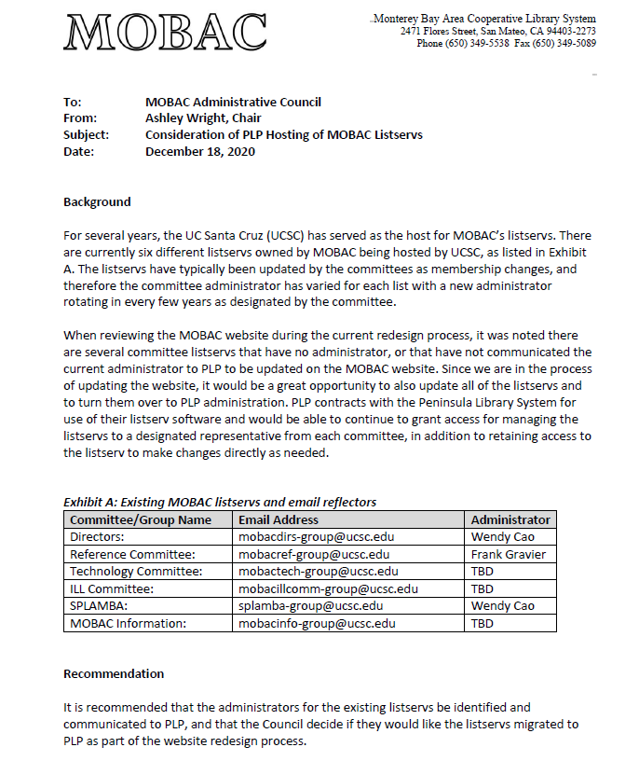

ATTACHMENT 2

