Annual Report to the MOBAC Administrative Council

Fiscal Year: 2019

Committee: MOBAC Interlibrary Loan Committee

Committee Member & Chair: Irma Fink (NPS)

Active Committee Members: Rebecca Bergeon (CSUMB), Jean Chapin (HML), Rochelle Eagen (SJB), Irma Fink (NPS), Katya Haskin (MPC), Graham McGrew (SCZ), Ray Melendez (MCO), Mezairah Niduaza (HCL), Susan Renison (WAT), Donna Teresa (MPC)

Additional Resource Sharing Members: Claire Conklin (CAB), Rachel Becerra (GAV), (MIIS), Sandy Ekland (SBE), Tara Gooden (UCSC)

Date: July 9, 2019

- What did your committee accomplish during the last year?

- We held four (4) meetings throughout the fiscal year: July 10, 2018, October 9, 2018, January 8, 2019, April 9, 2019

- July 2018: we drafted the 2018 Annual Report (presented to Council in September 2018); updated the Committee roster; elected the FY 2018/2019 Chair (the member from MIIS, who left MIIS before he could serve as Committee Chair).

- October 2018: we received an external microphone to support ZOOM meetings (thank you to the MOBAC Technology Committee for facilitating this). This equipment will be held at Watsonville Public Library; we reviewed our Committee website and noted some areas where updates are needed; we discussed the importance of resource sharing and the value of networking.

- January 2019: we welcomed Rochelle Eagen from San Juan Bautista City Library

- April 2019: we welcomed new member Katya Haskin (MPC); we discussed ILL procedures for members who are unable to participate with OCLC WorldShare ILL. Most members are able to accept requests via email. We reviewed our Committee Charge:

The MOBAC Interlibrary Loan Committee is the advisory group, which makes recommendations to the MOBAC Administrative Council to improve and maintain interlibrary loan service throughout the System regarding efficient interlibrary loan communication, accurate interlibrary loan tools, and trained and efficient interlibrary loan staff.

We agreed the charge is appropriate as is.

- The Committee Chair and/or a committee member attended and reported at MOBAC Administrative Council meetings.

- We continued to add and update information posted to our MOBAC ILL Guidelines webpage http://www.mobac.org/committees/interlibrary-loan-committee/mobac-ill-guidelines-2/ ; we updated our calendar of activities http://www.mobac.org/committees/interlibrary-loan-committee/ill-committee-documents/ill-committee-meeting-calendar/ ; we updated our roster/contact list http://www.mobac.org/committees/interlibrary-loan-committee/

- Problem Sharing and Solving continue to be a component of each meeting as well as notices of upcoming ILL-related workshops and conferences.

- We are interested in the impact the Koha ILS Project and the ZIP BOOKS program may have/ are having on MOBAC Resource Sharing.

- What activities, workshops, etc. are you planning for the coming year?

- We will continue to explore ILL tools that facilitate the sharing of electronic resources and e-books.

- We will continue to monitor and update our webpage and the MOBAC ILL Guidelines as needed, adding useful links and ILL “best practice” tips.

- We will reach out to members unable to attend meetings to solicit input for the meetings. We will continue to encourage meeting participation via ZOOM.

- We will reach out to library directors to encourage participation in resource sharing among all MOBAC members.

- We will continue to monitor ILL-relevant webinars and workshops and may ask to host a workshop in the coming year.

- Are there any obstacles/issues/challenges you wish to convey?

Obstacles and challenges include:

- MOBAC member library staff and library patrons are unable to see accurate library holdings through WorldCat due to libraries not having updated their OCLC records. Additional layers of searching (searching a specific library's catalog rather than WorldCat) are required for library staff and patrons to see the holdings of all member libraries.

- Some MOBAC members no longer maintain their holdings in OCLC. This also contributes to inaccurate records and creates additional work for ILL and other staff. The inability to find items becomes a barrier to local resource sharing.

- Due to the changing nature of digital content, we are working to keep up with new technologies.

We request that Council encourage full participation of MOBAC member libraries in resource sharing.

We request that Council encourage full participation of member libraries' designated ILL Committee representatives at quarterly ILL Committee meetings.

We ask that Council help the Committees as needed to post their meeting dates and minutes promptly to the MOBAC website. It is difficult to keep up with the activities and meetings if they are not posted. We note that PLP has offered to help with this challenge and that it has been included in the draft of the MOBAC Committee Chair Responsibilities.

Annual Reports are posted to our Committee website:
http://www.mobac.org/committees/interlibrary-loan-committee/ill-committee-documents/ill-committee-annual-reports/

Annual Statistics – FY 2019 (July 1, 2018 – June 30, 2019)

The following statistics represent the Borrowing and Lending processes for both Within System (WIS) and Out of System (OOS) ILL for Loans (returnable materials) and Copies (articles and other non-returnable materials). These statistics represent ILL transactions processed through OCLC and do not reflect ILL transactions performed using other sources. Per OCLC, only requests that have an OCLC ILL record number as part of the request are counted.

Statistics indicate that for FY 2019 within system ILL resource sharing for both Borrowing and Lending to be approximately 14% of total ILL activity. We have seen a steady downward trend since full-member participation in FY 2009 where within system Borrowing was at 25% of total Borrowing and within system Lending was at 28% of total Lending. While DLI withdrew from MOBAC membership effective July 1, 2018, they did continue to do some resource sharing with us and so we have included their statistics with this report.

The two (2) tables below represent the percent of Within System Borrowing .vs All Borrowing (Within and Out of System) for Loans and Copies (blue table) AND Within System Lending .vs All Lending (Within and Out of System) for Loans and Copies (green table) by MOBAC member library for FY 2019. (Note: N/A indicates no data reported.)

A sampling of charts (Chart 1 through Chart 8) for both Borrowing and Lending processes for FY 2019 are shown below. Additional data for this FY and prior years can be viewed at our Annual Statistics website.

MOBAC MEMBER  LIBRARY | % of WITHIN SYSTEM BORROWING .VS ALL BORROWING  LOANS – FY 2019 | MOBAC MEMBER  LIBRARY | % of WITHIN SYSTEM BORROWING .VS ALL BORROWING  COPIES – FY 2019
CAB | 32% | CAB | 29%
CSUMB | 6% | CSUMB | 2%
DLI | N/A | DLI | N/A
GAV | 44% | GAV | N/A
HCL | 23% | HCL | N/A
HML | 28% | HML | 7%
MCO | 12% | MCO | N/A
MIIS | 26% | MIIS | 12%
MPC | 16% | MPC | 11%
MPL | NON-PARTICIPANT | MPL | NON-PARTICIPANT
NPS | 12% | NPS | 0%
PGR | NON-PARTICIPANT | PGR | NON-PARTICIPANT
SAL | NON-PARTICIPANT | SAL | NON-PARTICIPANT
SBE | 44% | SBE | N/A
SCZ | 17% | SCZ | 25%
SJB | NON-OCLC PARTICIPANT | SJB | NON-OCLC PARTICIPANT
UCSC | 2% | UCSC | 0%
WAT | 31% | WAT | N/A

MOBAC MEMBER  LIBRARY | % of WITHIN SYSTEM LENDING .VS ALL LENDING  LOANS – FY 2019 | MOBAC MEMBER  LIBRARY | % of WITHIN SYSTEM LENDING .VS ALL LENDING  COPIES – FY 2019
CAB | N/A | CAB | N/A
CSUMB | 13% | CSUMB | 3%
DLI | 3% | DLI | 0%
GAV | 26% | GAV | 33%
HCL | 59% | HCL | 100%
HML | 36% | HML | 10%
MCO | 14% | MCO | 0%
MIIS | 51% | MIIS | 3%
MPC | 38% | MPC | 0%
MPL | NON-PARTICIPANT | MPL | NON-PARTICIPANT
NPS | 5% | NPS | 1%
PGR | NON-PARTICIPANT | PGR | NON-PARTICIPANT
SAL | NON-PARTICIPANT | SAL | NON-PARTICIPANT
SBE | 89% | SBE | N/A
SCZ | 7% | SCZ | N/A
SJB | NON-OCLC PARTICIPANT | SJB | NON-OCLC PARTICIPANT
UCSC | 8% | UCSC | 2%
WAT | 12% | WAT | 0%

ILL Borrowing Charts
Chart 1
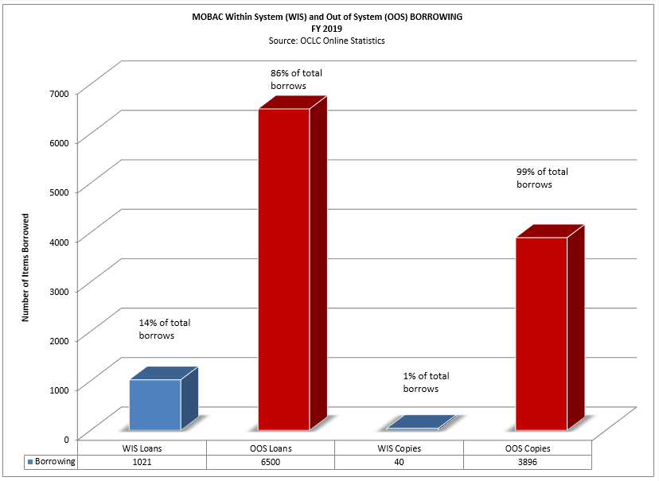

Chart 2
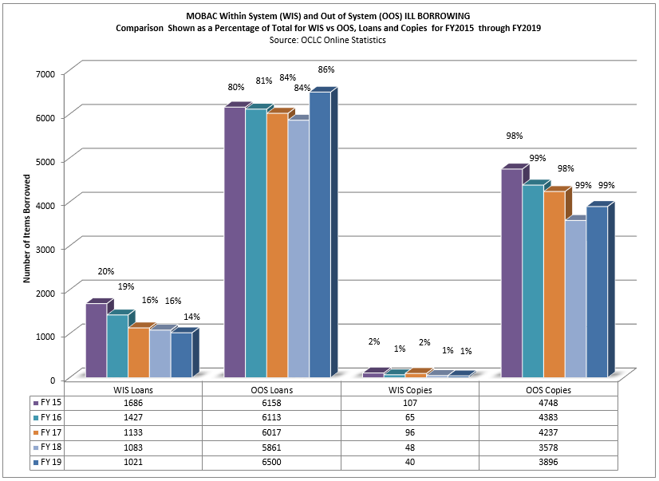
Chart 3
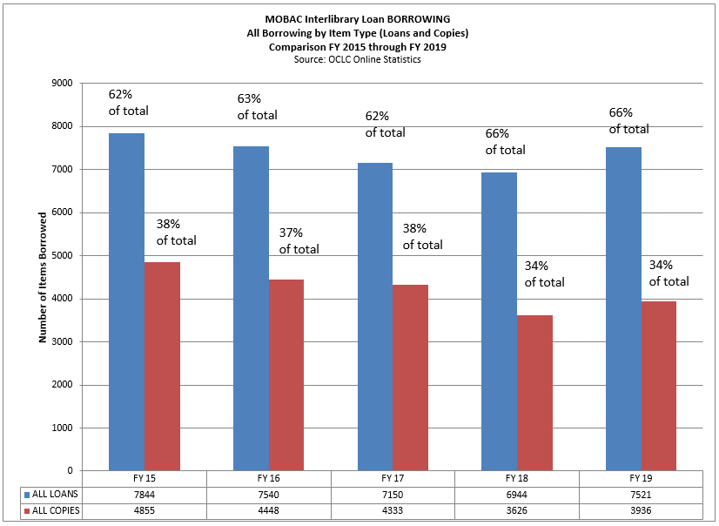

Chart 4
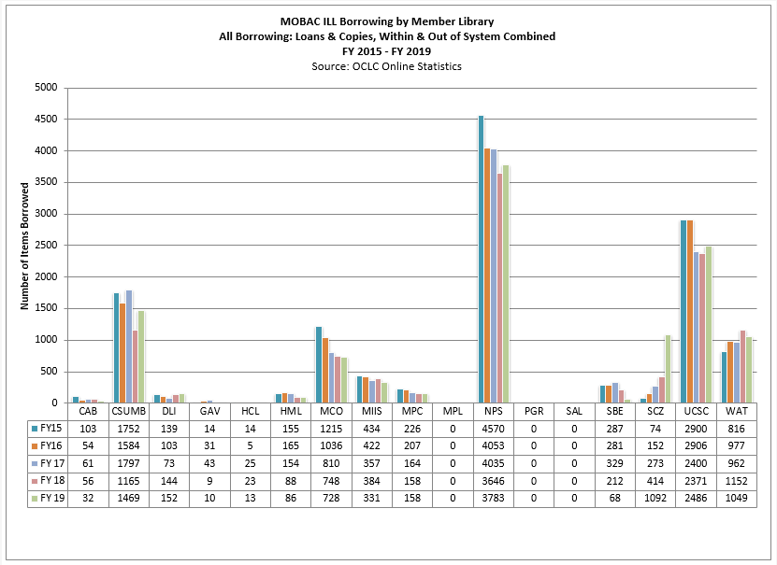

ILL Lending Charts
Chart 5
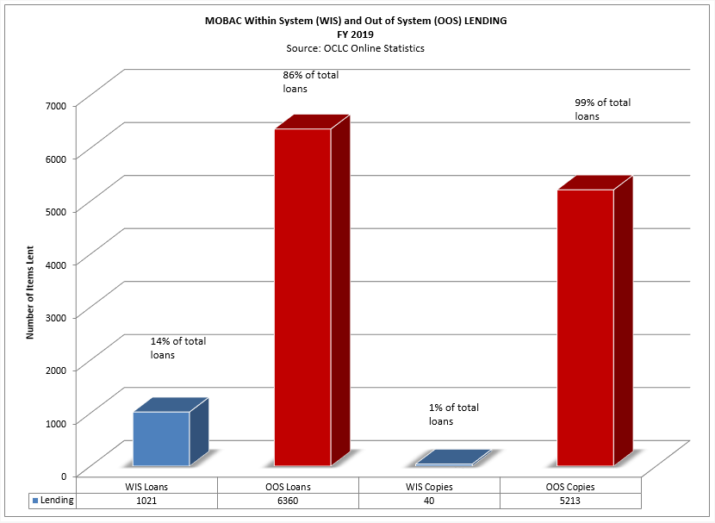

Chart 6
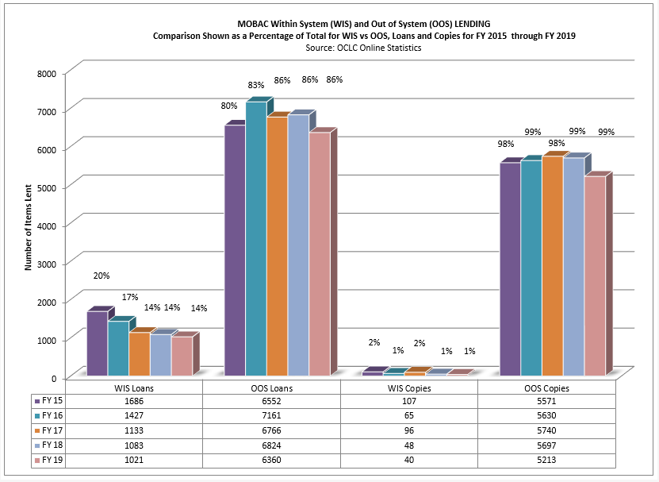
Chart 7
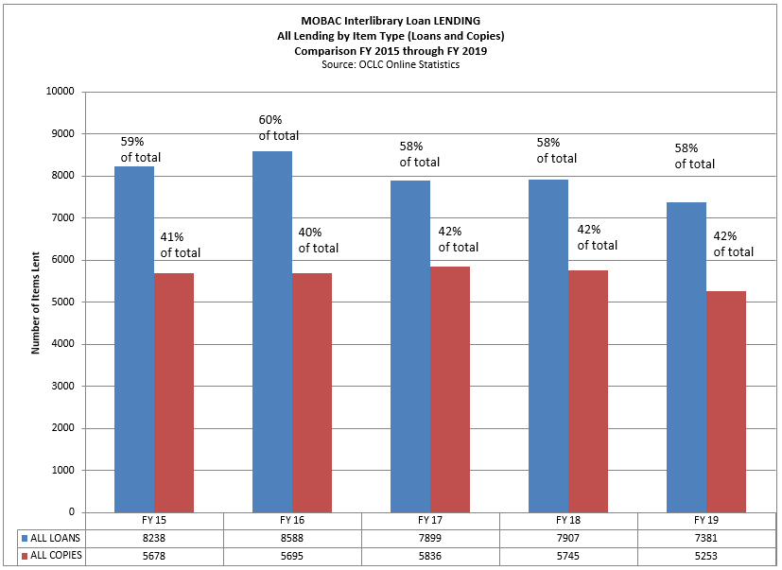

Chart 8
